**What is ADAS?**

‍

THE ADAS (*Advanced Driver Assistance Systems*) is a set of intelligent systems integrated into modern vehicles to assist the driver and reduce the risk of accidents. These advanced systems provide important information about road traffic, road closures, congestion warnings, and alternative routes. In addition, ADAS accurately assesses driver fatigue levels and distractions, offering alerts and suggestions for improving driving. Thanks to these functionalities, ADAS systems play an essential role in improving road safety and travel efficiency.

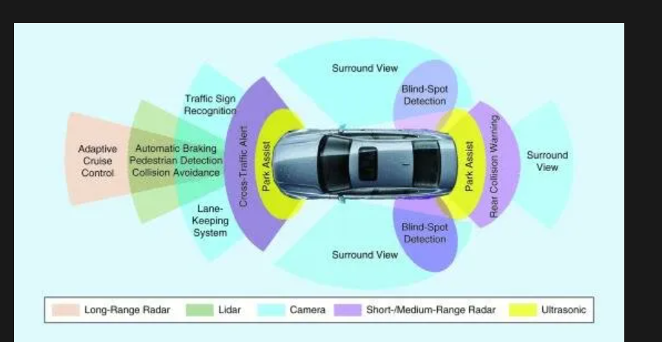

**What is ADAS annotation?**

‍

ADAS annotation, or data annotation for advanced driver assistance systems, involves [**identifying, labeling, and structuring information**](https://www.innovatiana.com/en/post/text-annotation-for-ai-models) captured by vehicle sensors, such as cameras, radars, and lidars. This data is very numerous and varied, and recent vehicles are being collected. So there is no limit, except for the constraint of blurring license plates in images and videos to ensure compliance with privacy regulations (which requires human intervention in the preparation of data used to train artificial intelligence models used for autonomous driving).

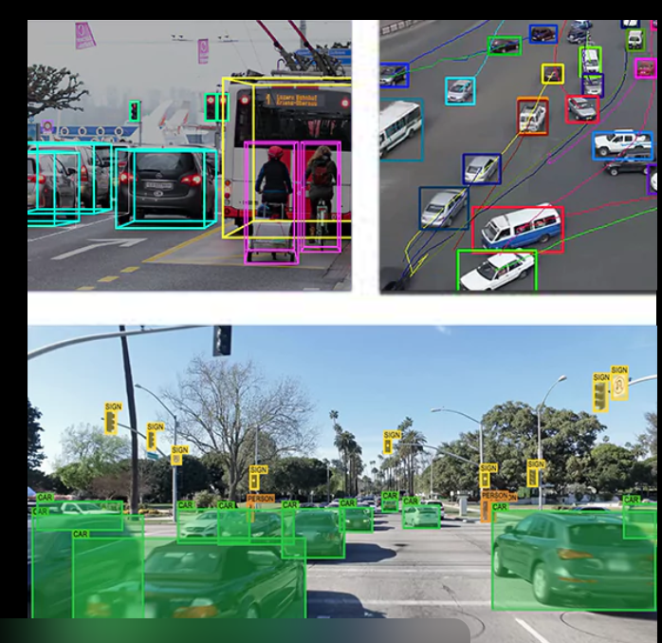 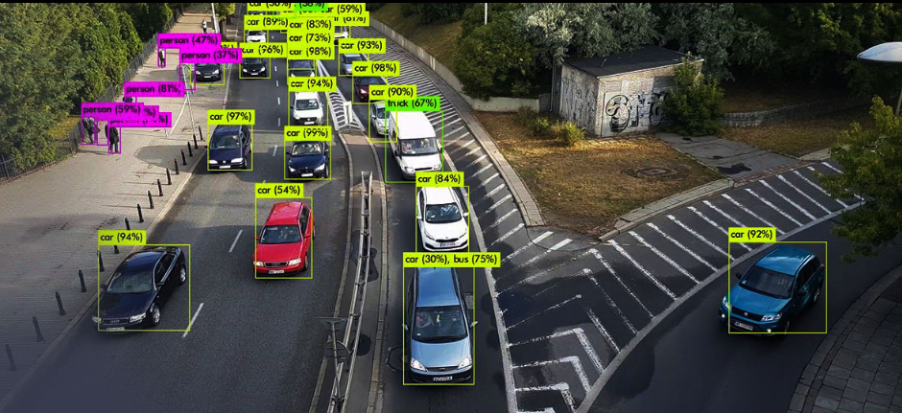

**Why is creating ADAS datasets essential?**

‍

This process is essential for training the artificial intelligence models that power ADAS systems. By learning from annotated data, models can recognize objects, assess situations, and make decisions in real time, increasing the safety and reliability of assisted and autonomous vehicles.

‍

The ADAS annotation thus makes it possible to translate the physical world into information usable by systems, playing a fundamental role in the development of autonomous driving and the continuous improvement of driver assistance technologies. The United States (and especially Tesla) is playing a significant role in this field, with increasing adoption of ADAS systems expected in the coming decades.

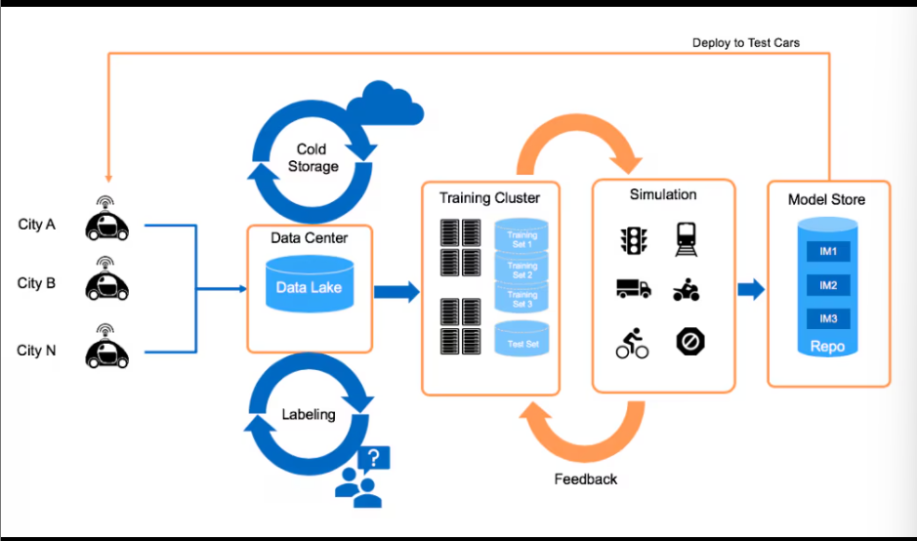

**How is ADAS data collected and annotated?**

‍

ADAS data is collected and annotated following several steps:

‍

**1. ADAS data collection: a network of embedded sensors**

ADAS data is collected through a network of sensors embedded in vehicles, including cameras, lidars, radars, and ultrasonic sensors.

‍

These devices capture a variety of information about the environment around the vehicle in real time, such as the position of objects, distances, the speed of moving objects, and other visual and audio elements, providing a complete view of the scene.

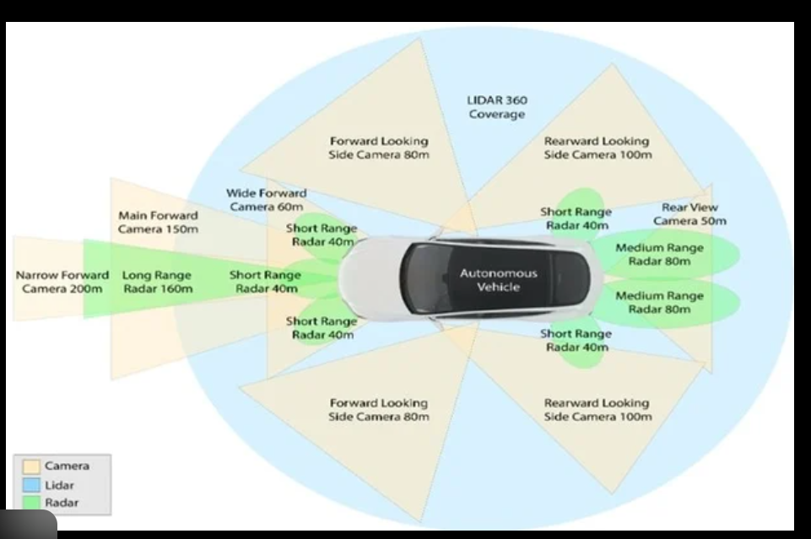

‍

**2. The annotation stage: transforming raw data into usable information**

Once the data is collected, it goes through an annotation phase. This process involves [**human annotators**](https://en.innovatiana.com/post/how-to-hire-data-annotators) as well as [**specialized annotation tools**](https://en.innovatiana.com/post/top-10-image-annotation-platforms-for-ai) to identify, label and classify the various elements captured by the sensors.

‍

Annotations can include boundary boxes for marking vehicles or pedestrians, lines for road markings, and dots for specific items like traffic lights.

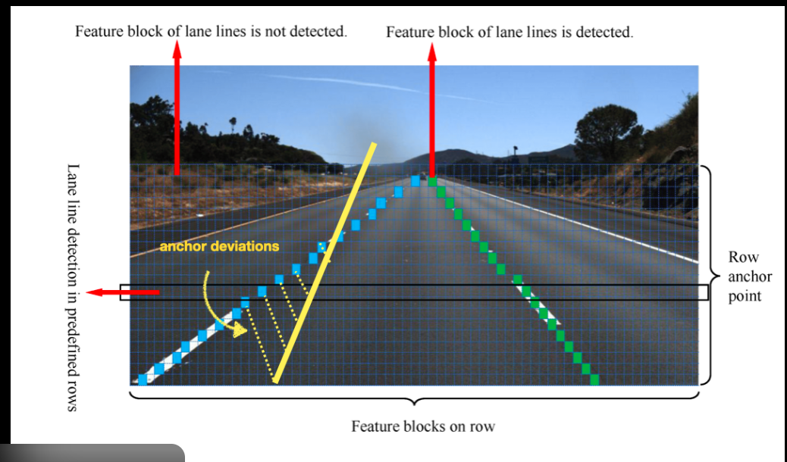

‍

**3. Automation and annotation tools: optimizing the process**

Annotation tools, such as ZF Annotate, facilitate annotation by automating tasks and speeding up the work of annotators. This partial automation reduces time and improves the accuracy of annotations, providing ADAS systems with high-quality data for learning.

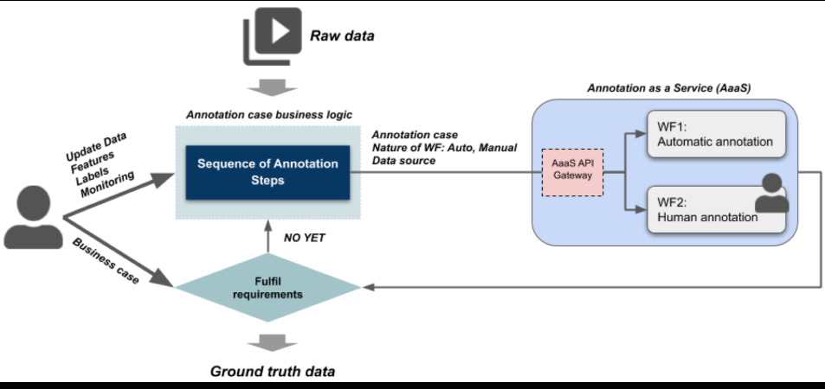

**4. Database storage: preparing data for learning ADAS systems**

Depending on the needs of the artificial intelligence models, the annotated data is then stored in a database. This database serves as a repository where annotations are organized and accessible, ready to be used to train algorithms.

‍

With this annotated database, ADAS systems can learn to detect and interpret various elements of the road, strengthening their ability to make informed decisions and respond effectively in real time.

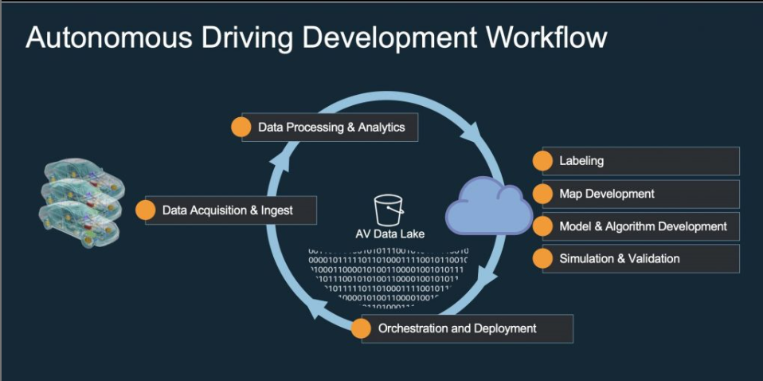

**What role does the database play in the ADAS annotation process?**

‍

The database (or dataset) plays a central role in the annotation process of ADAS systems, as it is the main repository where collected and annotated data is stored and organized.

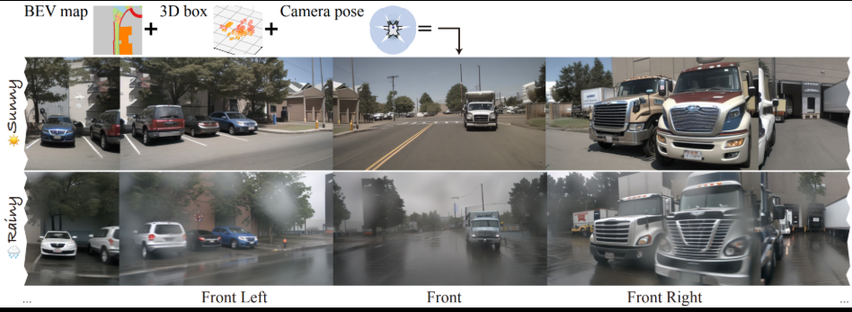

‍

**The database: a centralized repository for ADAS data**

‍

The database plays a central role in the process of annotating ADAS systems. It serves as the main repository, where all collected and annotated data is stored and organized.

‍

This centralized system makes it possible to combine information from sensors (cameras, lidars, radars) as well as associated annotations, thus forming a coherent and accessible data set for training artificial intelligence models.

‍

**Data diversity: a key factor for machine learning**

‍

By grouping together varied and annotated examples of road situations, the database exposes machine learning algorithms to a wide variety of scenarios. These examples include different road configurations and object behaviors in traffic, helping ADAS systems gain generalization capabilities.

‍

This means that they are better equipped to recognize and interpret elements of the environment, even in complex or novel situations.

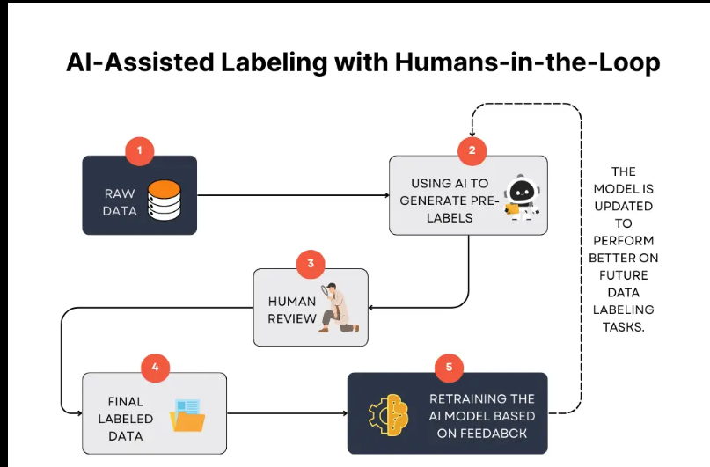

‍

**A tool for the continuous improvement of ADAS systems**

The database also facilitates the monitoring and continuous improvement of ADAS systems. By adding new annotated data and correcting possible errors in existing annotations, engineers can refine and adapt AI models to meet evolving security standards and market requirements.

‍

**Data quality: a pillar for the accuracy and reliability of systems**

The quality and richness of the data contained in the database are fundamental to ensure the accuracy and reliability of ADAS systems. A well-structured database rich in accurate annotations allows AI models to make safe decisions in real time, contributing to better and safer driving systems.

‍

‍

**Autonomous driving: challenges and opportunities**

Autonomous driving is a rapidly evolving field, presenting both challenges and significant opportunities. Challenges include the need to develop robust security systems, manage complex sensor data, and ensure compliance with privacy regulations. However, the opportunities offered by autonomous driving are numerous. It promises to significantly reduce road accidents, improve mobility for the elderly and disabled, and create new business models. By overcoming these challenges, autonomous driving could radically transform the way we travel.

‍

‍

**ADAS data management and security**

ADAS data management and security are critical to ensuring the reliability and safety of autonomous driving systems. Sensor data should be collected, processed, and stored securely to avoid data leaks and hacker attacks. Businesses should also have robust data retention policies and security protocols in place to ensure compliance with privacy regulations. By ensuring secure data management, ADAS systems can operate reliably and protect sensitive user information.

‍

‍

**Training and expertise for ADAS systems**

Training and expertise are essential elements for the development and maintenance of ADAS systems. Engineers and developers need a thorough understanding of sensor systems, data processing algorithms, and communication protocols. Businesses need to invest in the continuing education of their employees to ensure that they are up to date with the latest technology and best practices. This expertise makes it possible to develop more efficient ADAS systems and to guarantee their efficiency and safety over the long term.

‍

In addition, the expertise required for the preparation of ADAS datasets is also overlooked. It seems important to us to remember that Data Labeling is a job: it is not a question of annotating successive images without reflection, but on the contrary of having a critical eye and a sense of detail to detect atypical cases and prepare diversified data sets.

‍

‍

**How does ZF Annotate contribute to data annotation for ADAS systems?**

‍

[**ZF Annotate**](https://www.zf.com/)is a cloud-based validation service with artificial intelligence, designed to optimize the annotation of data for advanced driver assistance systems (ADAS). By providing [**accurate “ground truth”**](https://www.innovatiana.com/en/post/ground-truth-in-ai), it accelerates the development and validation of ADAS systems.

‍

**Benchmark data collection**

ZF Annotate uses a set of independent reference sensors, installed either on the vehicle under test or on a dedicated tracking vehicle. These sensors record detailed environmental data while driving, serving as a basis for the validation of ADAS systems.

**Automated annotation using artificial intelligence**

The collected data is then uploaded to the cloud, where artificial intelligence algorithms identify, classify, and track relevant objects in 2D and 3D. This process generates accurate annotations, reducing the need for human intervention and improving efficiency. However, final validation by human intervention remains necessary

**Improving accuracy and speed**

Thanks to automation, ZF Annotate speeds up the annotation process up to ten times compared to manual methods, while reducing costs by up to 80%. This efficiency allows ADAS developers to validate and train their models more quickly and cost-effectively. However, this does not exclude the process of annotating manual data: on the contrary, it is imperative that humans review the sets of [**pre-annotated data**](https://en.innovatiana.com/post/pre-labeling-for-ai) with a critical eye.

‍

**Extensive flexibility and compatibility**

ZF Annotate is compatible with various sensor manufacturers and can be integrated into various development projects, offering valuable flexibility for engineers working on ADAS systems.

**Future trends in ADAS systems**

‍Future trends in ADAS systems include the integration of artificial intelligence (AI) and deep learning to improve the accuracy and reliability of autonomous driving systems. Businesses will also need to develop more robust security systems to protect sensor data and communication systems. In addition, ADAS systems will increasingly be integrated into electric and hybrid vehicles.

**Conclusion**

‍

Data annotation for ADAS systems is an essential step in the development of autonomous driving. By centralizing data, ensuring accurate annotations, and using advanced tools like ZF Annotate complemented by the meticulous work of qualified Data Labelers, automakers and AI engineers have the resources they need to train intelligent models that can respond safely and effectively to various road challenges.

‍

These technological advances, made possible by rigorous annotation and reliable reference data, shape a future where autonomous vehicles can interact harmoniously with their environment, thus improving the safety and efficiency of travel.

